# Wiz Coasts

## Oil Exploration Co. Ltd

RC 1394304

Know Wizcoast Oil! Know quality products!

# Wiz Coasts

## Oil Exploration Co. Ltd

RC 1394304

No 20 Ada-george Road, Okilton Junction, Port Harcourt, Rivers State. **08090750435**

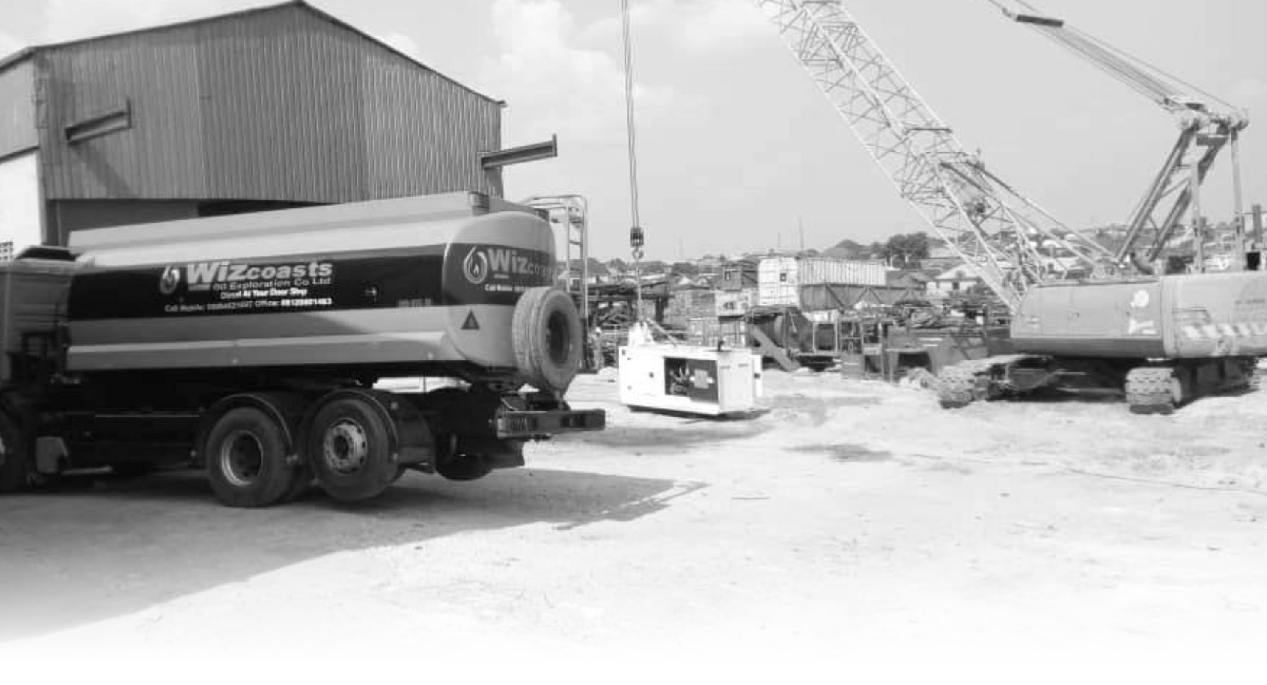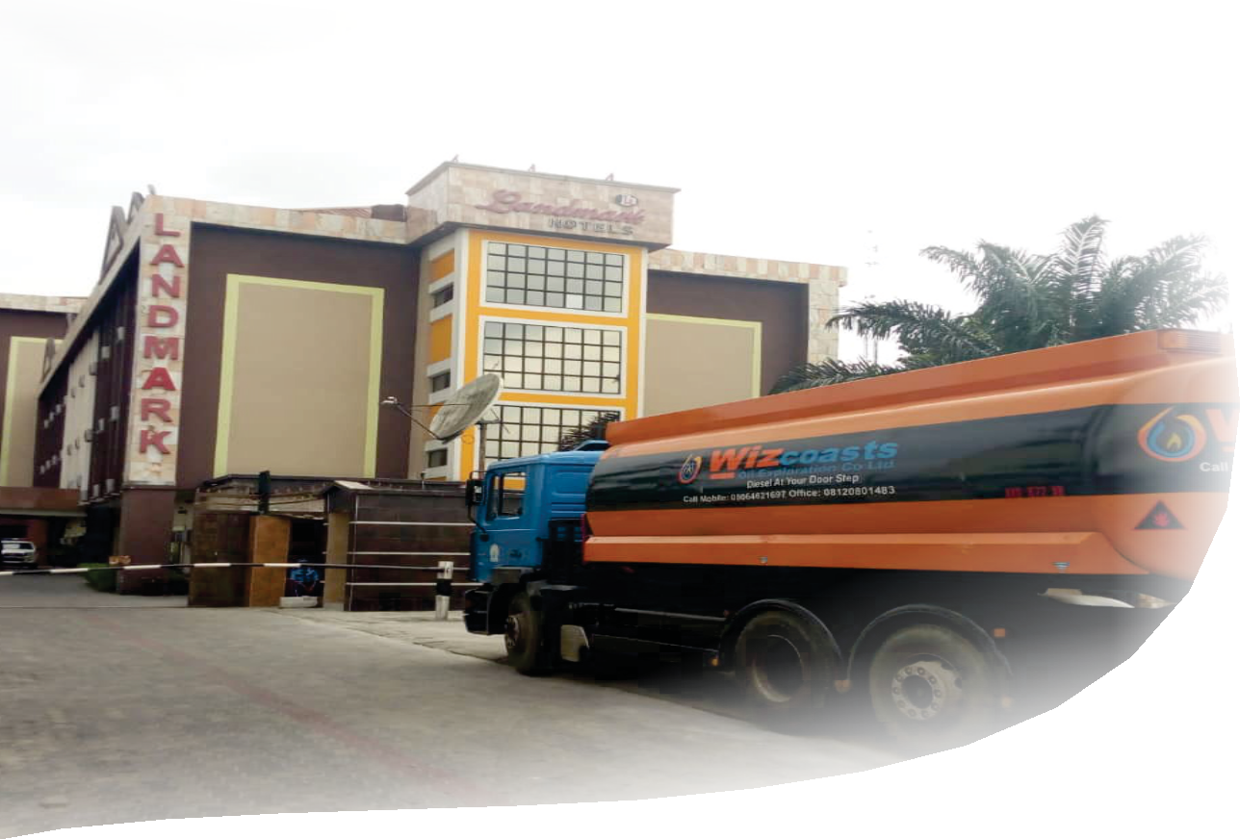

™ [wizcoastoil@gmail.com](mailto:wizcoastoil@gmail.com) [Wizcoastsoilexploration123@gmail.com](mailto:Wizcoastsoilexploration123@gmail.com)

Company **Proﬁle**

OUR SERVICE

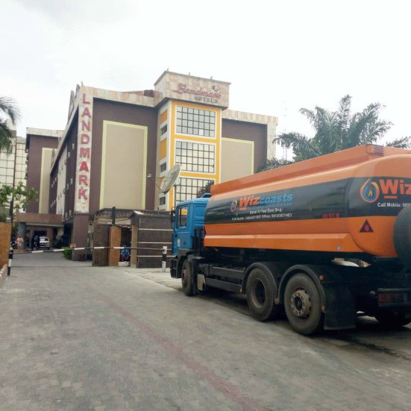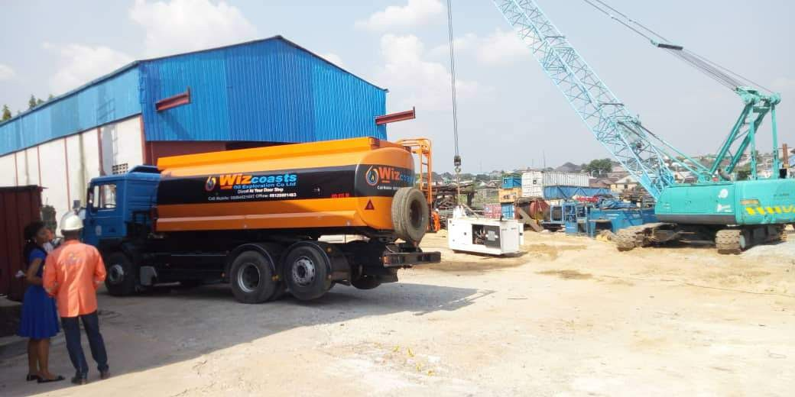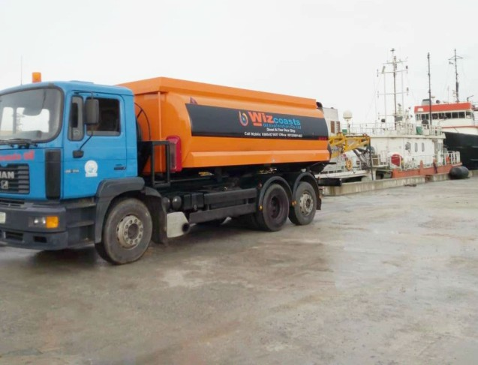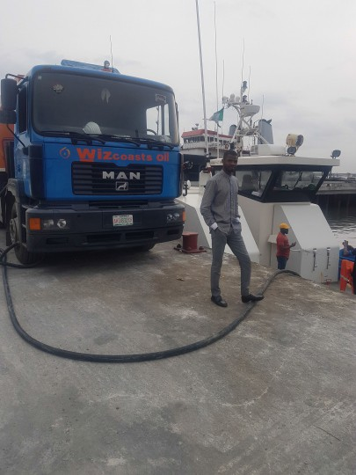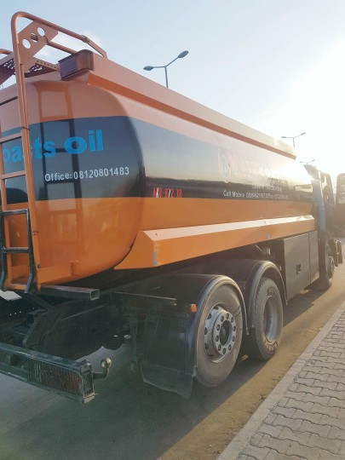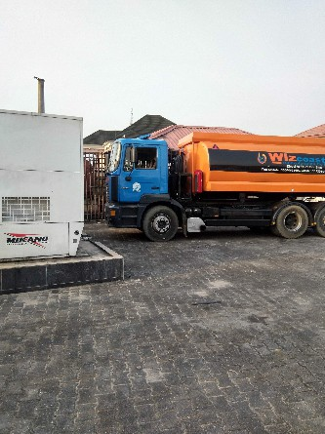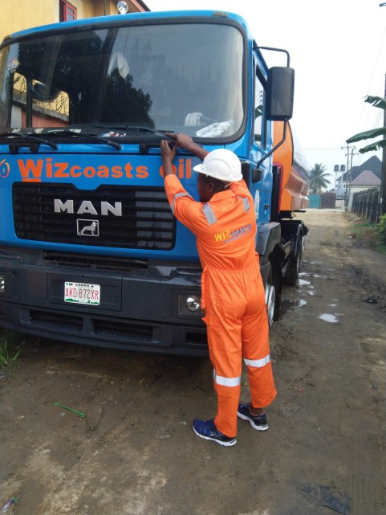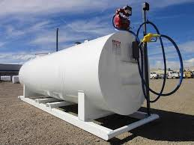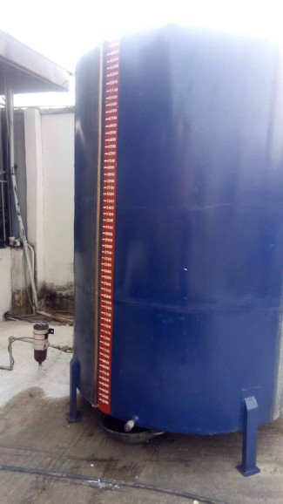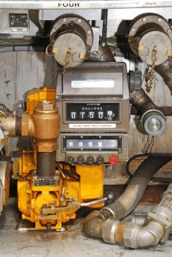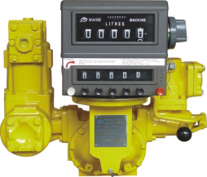

**TRUCKS**

**Wiz Coasts**

Oil Exploration Co. Ltd

RC 1394304

OUR STORAGE/METERING

**FACILITY**

OUR

**COMPANY**

WIZCOASTS Oil is a registered Indigenous contracting company, under the Cooperate Affair Commission, Federal Republic of Nigeria with Registration No RC 1394304 having its Head ofﬁce in Port Harcourt.

Wizcoasts Oil Exploration Company limited is a petroleum company involved in Importation, Marketing, Offshore supply, and Peddling of Petroleum products. We are also involved in the supply of Exploration & Production materials and equipment's.

We also have a Registered Trade Mark that bears the same reputation of our parent company in door to door delivery of petroleum product (otherwise known as Peddling) to our customers.

### VISION STATEMENT

To be a world–class exploration and supply company delivering future value to all stakeholders.

### MISSION STATEMENT

To sustain and deliver proﬁtable solutions through operational e x c e l l e n c e a n d e f f e c t i v e workforce.

WIZCOASTS | 01

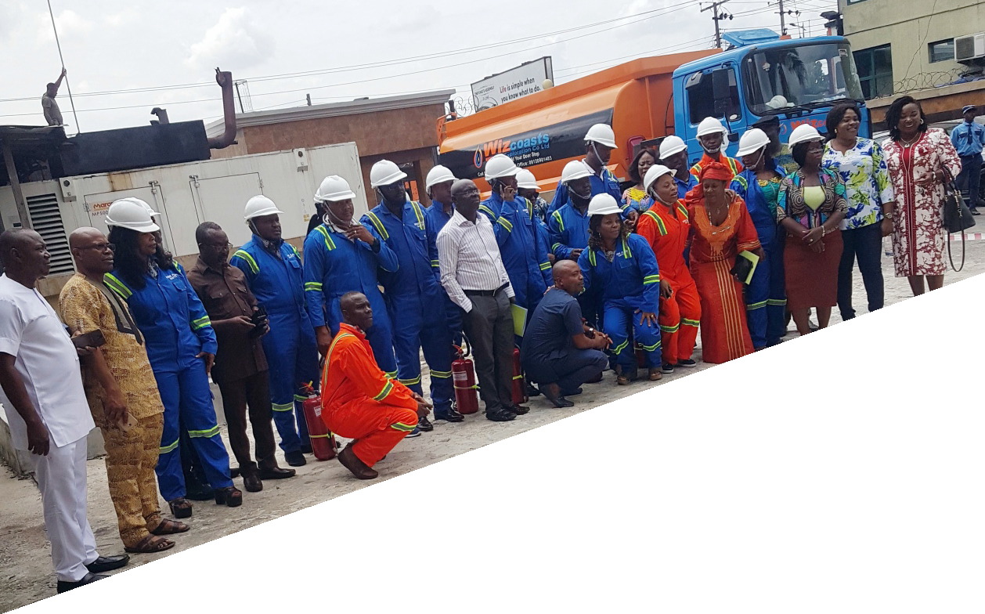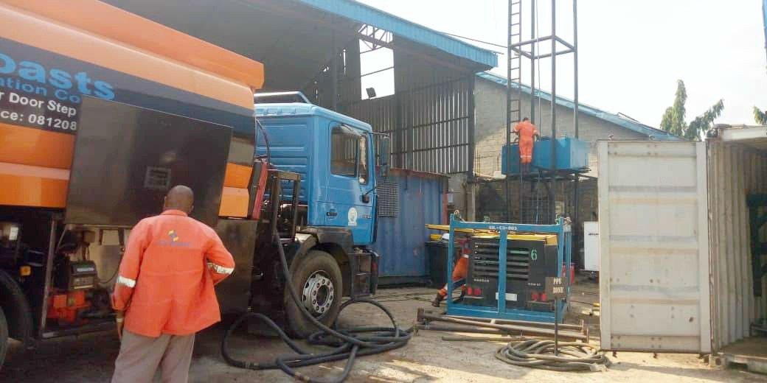

WIZCOASTS | 02

WISCOAST

**OIL**

Wizcoasts Oil carry out the business of petroleum product peddling, which includes Logistics, Supply and Distribution of all kinds of Petroleum products within and outside Port Harcourt Metropolis with our well branded trucks, calibrated meters meeting all SGS standards.

**OUR SERVICES**

#### AND FUNCTIONS

**Supply and Distribution of Petroleum Products**

WISCOAST oil carry out the supply and distribution of all Petroleum products namely diesel (AGO), kerosene (DPK), etc. We lift our products from registered dealers of petroleum products such as Forte Oil, Conoil Plc, Oando Plc, and NNPC reﬁnery etc. We also ensure that distribution of products to our customers is swift and efﬁcient. Our target customers include residential homes, ofﬁce complex, banks, hotels, small & large scale industrial concerns etc. We also do Bulk buying and delivery both Offshore and Onshore solely handled by our parent company.

#### Sterilization/cleaning of Storage Tanks

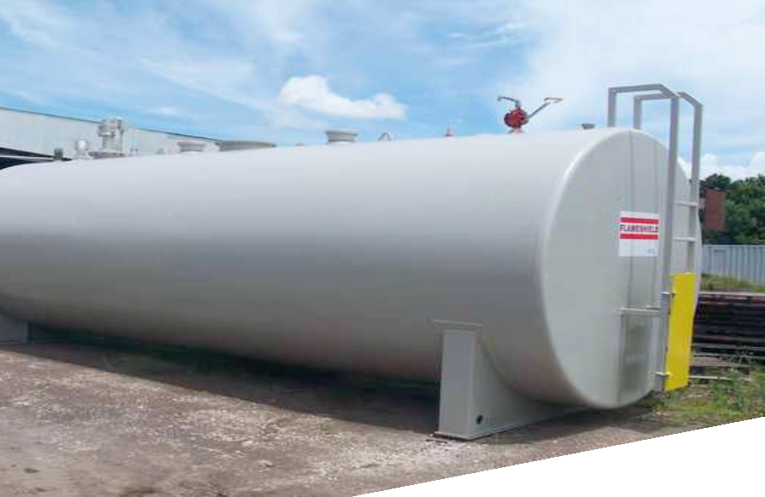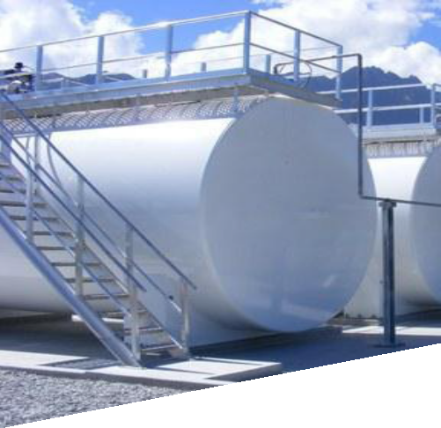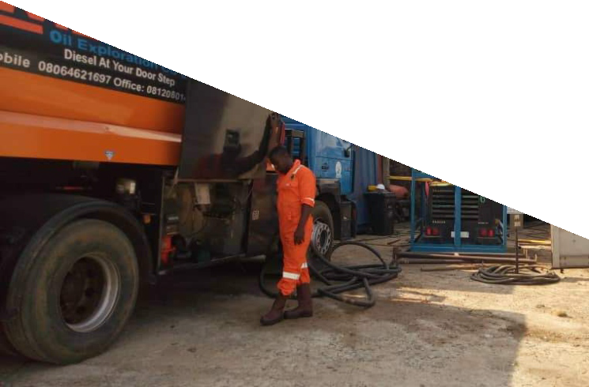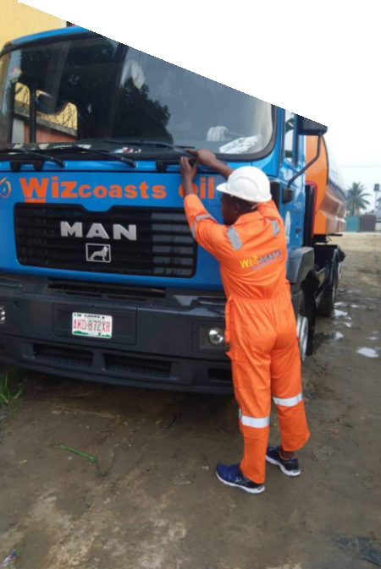

**Procurement of Standard Storage Facility**

In view to the nature of our business, we assist our clients in securing standard tanks that guarantee safety of product, equipment and human lives.

We undertake the sterilization of storage tanks. This is necessary to discard dirt and scum that settle at the bottom of the tanks. These dirt or scum when not often removed can cause great damage to sensitive parts of the generating set like creating blockage along nozzles of injector pumps and fuel line. A routine removal of these dirt (say once every quarter of the year) enhances the lifespan of the generating set.

#### Logistics and Methods

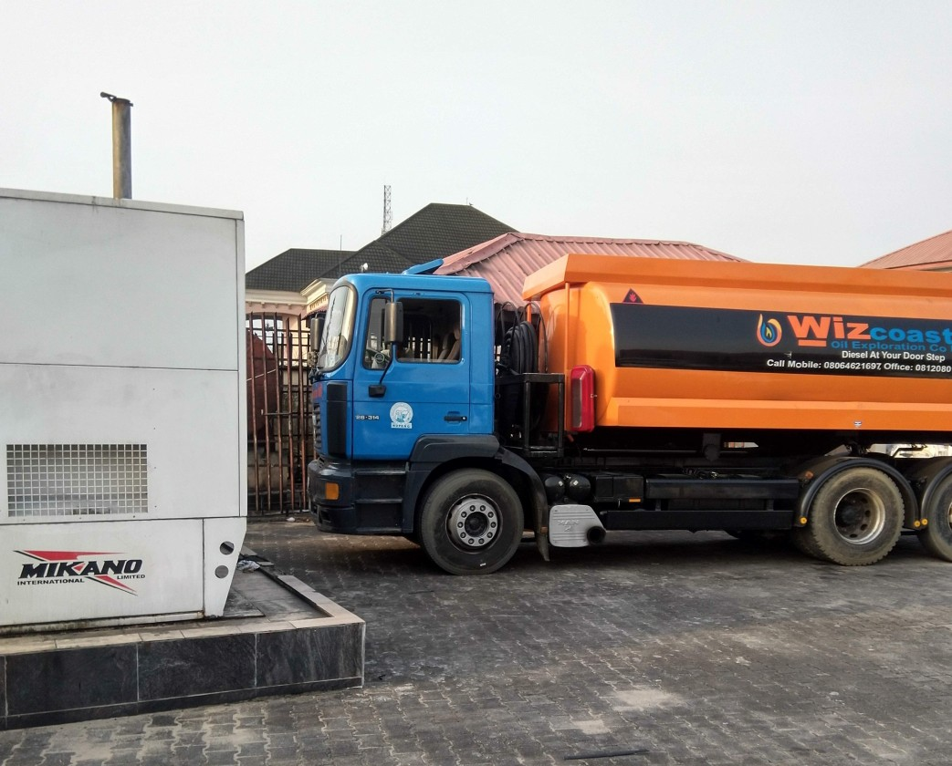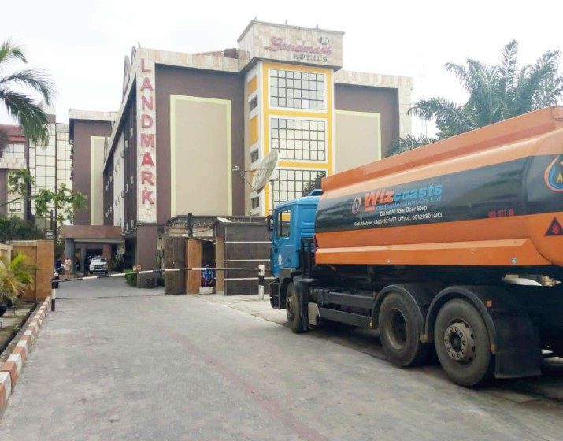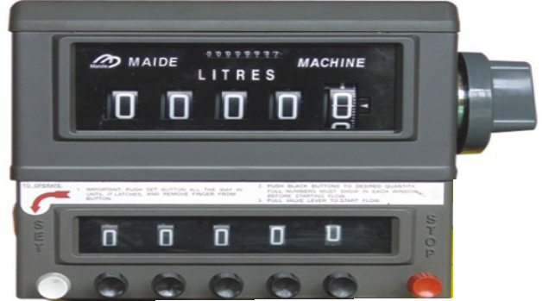

Our services and functions are not limited to the above mentioned areas. We also undertake haulage/transportation of all kinds of product. Detailed hereunder are some of the strategies we adopt in accomplishing our customers demand satisfactorily.

#### Calibrated Conveying Tanker Trucks

We have a ﬂeet of tanker trucks with calibrated aluminum tanks that convey products to any location within and outside Port Harcourt Metropolis at the shortest possible time. Our 200,000 liters capacity storage facility further gives us a leverage of maintaining a schedule of track delivery with our clients, even when there is acute shortage of product; we ensure that the demands of our customers are satisﬁed.

#### Metering Facility

Our delivery trucks have customized metering facility which is duly certiﬁed by SGS Company and approved by our esteemed customers. Please see the appendix for the picture of our metering system. We ONLY add taste to our services by carrying the product to our customers' door step with ease!

#### ·Storage Facility

We have a mini-storage facility with an average capacity of approximately 200,000 liters. This enables us meet with the demand of our esteemed customers even in the era of scarcity of product. This has also given us an edge amongst our contemporaries in the business over time.

#### Quality Assurance Policy

Our products are adulteration-free as we are keen about the service of the products which we sell to our customer. We ensure that our products are sourced from licensed petroleum dealers. More often than not, we insist that our product should be tested with recommended reagents to ascertain the quality of same, before dispensing. The speciﬁcation for our product agrees perfectly with that of Standard O r g a n i z a t i o n o f N i g e r i a ( S O N ) a n d Department of Petroleum Resources (DPR) speciﬁcation.

**Flash Point Test:** This helps to determine the maximum temperature at which a sample product will ignite when heated. This is used to establish the presence of condescend, kerosene, bitumen liquor, etc., in the product.

**Density test:** Every substance has unique density. The density of any substance speaks volumes of its purity. Hence we carry out density test on our product to ascertain their purity.

**Litmus Paste Test:** This indicator reveals the presence or absence of water molecule in the product by change of color from orange to red.

#### Product Price

The prices for our products are subject to review at the depot without notice. Our sale prices are based on purchase price and other incidental charges incurred during loading. Please see details of the current price list for the various products as stated hereunder for your consideration.

**PRESENT CLIENTS:**

1. Flow Grids Limited

Mrs. Elizabeth Akemu 08036722995

1. Sundry foods

Madam Mariam – 08038100314

1. Vandrezzer Energy Services Mr. Ola- 08033526809
2. PSL Engineering

Mr. Femi – 07032637328

1. Admiral Marine

Mr. George - 08033168083

1. Hope spring foundation school.

Mrs. Emyle- 08033095363

1. Living faith church Choba Mr. moses-08063749212
2. O K I Engineering

Mr. Eke - 08086666081

1. Living Faith Church Rumuogba Pastor Chidi – 08036773873
2. Domino Pizza

Mr. Charles Ewah - 08034653035



We look forward to hearing from you soonest and also available to discuss further as prices are negotiable from time to time.

|  |  |  |
| --- | --- | --- |
| **Product** | **Current Price Per Litre (Naira)** | |
| **Payment on delivery** | **With two weeks** |
| **Diesel (Ago)** | **Prevailing market price** | **Negotiable** |